Product Outline: Single Use Emergency PPE Visor

Concept:

A flat-packed, self-assembly single use, optically clear visor to protect the eyes, nose, mouth (face in general) from contaminated droplets for emergency use in the field.

Packaging:
Cartons of 100 units

Supply capability

200,000 units per day ex Portsmouth, United Kingdom

Instructions:
Remove the backing from the first adhesive tab, and attach to…

Assembly video: https://drive.google.com/open?id=1144k6QNRCdZzHXCwZtgxujdd4ejchYQ0

Images:
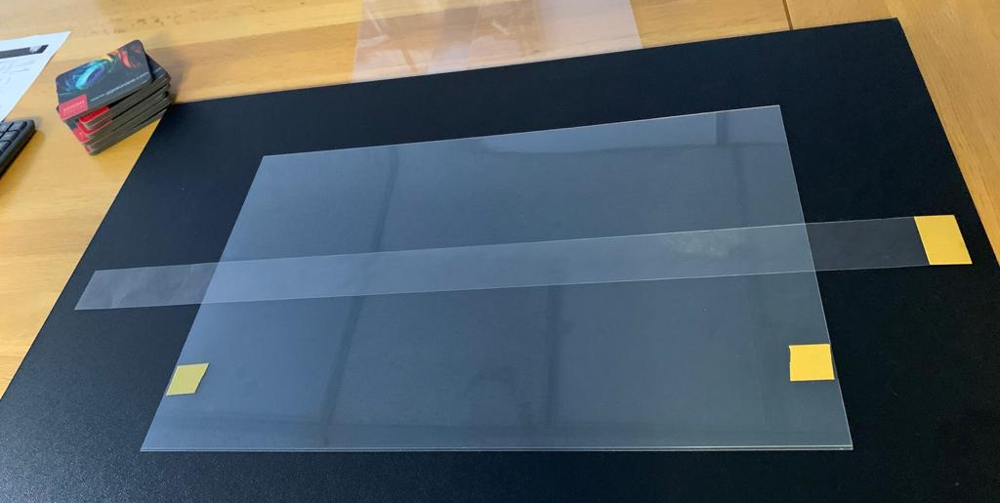

Flat-packed visor ready for assembly
